**VELAMMAL BODHI CAMPUS**

**(A CBSE – IIT/NEET Integrated Sr. Sec. School)**

**GRADE:** X **- Batch II PART TEST – 2 SUB:** SCIENCE (086)

**DATE:** 07.11.2023  **MARKS:** 80 (3 HOURS)

***General Instructions:***

*i. This question paper consists of 39 questions in 5 sections.*

*ii. All questions are compulsory. However, an internal choice is provided in some questions. A student is expected to attempt only one of these questions.*

*iii.* ***Section A*** *consists of 20 objective type questions carrying 1 mark each.*

*iv.* ***Section B*** *consists of 6 Very Short questions carrying 02 marks each. Answers to these questions should in the range of 30 to 50 words.*

*v.* ***Section C*** *consists of 7 Short Answer type questions carrying 03 marks each. Answers to these questions should in the range of 50 to 80 words*

*vi.* ***Section D*** *consists of 3 Long Answer type questions carrying 05 marks each. Answer to these questions should be in the range of 80 to 120 words.*

*vii.* ***Section E*** *consists of 3 source-based/case-based units of assessment of 04 marks each with sub-parts.*

**SECTION A**

1. Electrical resistivity of any given metallic wire depends upon

a) its thickness b) its shape c) nature of the material d) its length

2. Which of the following gases are filled in electric bulbs?

a) Helium and Neon b) Neon and Argon

c) Argon and Hydrogen d) Argon and Nitrogen

3. An electric fuse works on the:

a) chemical effect of current b) magnetic effect of current

c) lighting effect of current d) heating effect of current

4. The magnetic field lines in the middle of the current-carrying solenoid are:

a) circles b) spirals

c) parallel to the axis of the tube d) perpendicular to the axis of the tube

5. **One mole of which of the following compounds requires 2 moles of hydrogen to form a saturated hydrocarbon by catalytic hydrogenation?**

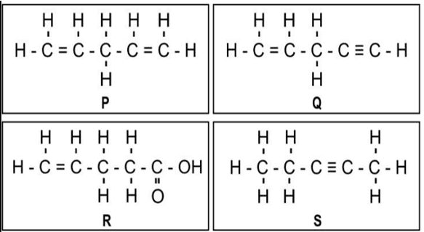

**a) Only P and Q b) Only R and S c) Only P and S d) Only P, Q, and S**

**6. The soap molecule has a**

**a) Hydrophilic head and a hydrophobic tail b) Hydrophobic head and a hydrophilic tail**

**c) Hydrophobic head and a hydrophobic tail d) Hydrophilic head and a hydrophilic tail**

7. Which of the following pairs will give displacement reactions?

a) NaCl solution and copper metal b) MgCl2 solution and aluminum

c) FeSO4 solution and silver metal d) AgNO3 solution and copper

8. Which of the following method is suitable for preventing an iron fry pan from rusting?

a) Applying grease b) applying paint

c) Applying coating of zinc d) All of the above

9. An element reacts with oxygen to give a compound with a high melting point. This compound is also soluble in water. The element is likely to be

a) Calcium b) Carbon c) Silicon d) Iron

10. Food cans are coated with tin and not zinc because

a) Zinc is costlier than tin b) Zinc has higher melting point

c) Zinc is more reactive than tin d) Zinc is less reactive than tin

11. Which of the following is not caused by a growth movement?

a) Bending of the shoot of plant in response to light

b) Closing up of leaves of a sensitive plant on touching with an object

c) Climbing up of a plant on an object by using tendrils

d) Movement of the root of a plant towards a source of water

12. What is the genotypic ratio of dihybrid cross

a) 3:1 b) 1:2:1 c) 9:3:3:1 d) 1:2:1:2:4:2:1:2:1

13. A man with blood group homozygous A marries a woman having blood group AB. What will be the blood group of the child?

a) A only b) A and AB only c) AB only d) A and B only

14. Which of the following receptors recognise taste

a) Gustatory b) Olfactory c) Auditory d) Tango

15. Multiple fission occurs in

a) Yeast b) Hydra c) Planaria d) Plasmodium

16. The future root developed from plant embryo is

a) Plumule b) seed coat c) Cotyledons d) Radicle

**Question no 17 to 20 is based on Assertion (A) and Reason (R). Answer these questions selecting the appropriate option given below:**

a) Both assertion (A) and reason (R) are true and reason (R) is the correct explanation of assertion (A)

b) Both assertion (A) and reason (R) are true but reason (R) is not the correct explanation of assertion (A)

c) Assertion (A) is true but reason (R) is false

d) Assertion (A) is false but reason (R) is true

17. Assertion (A): The magnitude of the magnetic field at a point on the axis of a current carrying solenoid is inversely proportional to the current flowing through the solenoid.

Reason (R): The magnitude of the magnetic field at a point on the axis of a current carrying solenoid is directly proportional to the number of turns per unit length of a solenoid.

18. **Two statements are given – one labeled Assertion (A) and the other labeled Reason (R). Select the correct answer from the option given below.**

**(a) Assertion (A):** Following are the structural isomers of butane.

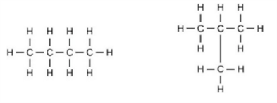

**Reason (R):** Structural isomers have the same molecular formula but they differ in their structures.

19. **Assertion (A):** Detergents are more effective cleansing agents than soaps in hard water.

**Reason (R):** Calcium and magnesium salts of detergents are water-soluble.

20. Assertion (A): A geneticist crossed two pea plants and got 50% tall and 50% dwarf in the progeny.

Reason (R): One plant was heterozygous tall and the other was dwarf.

**SECTION B**

21. Calculate the number of electrons that flow per second to constitute a current of one ampere. Charge on an electron is 1.6 x 10-19 C.

OR

Draw an electric circuit for studying Ohm's law. Label the circuit component used to measure electric current and potential difference.

22. a) Compare the structures of benzene and cyclohexane by drawing them.

OR

b) Why do ionic compounds have high melting points?

23. With the help of suitable diagrams, explain the various steps of budding in Hydra?

24. Why is it advised to take Iodised salt?

25. Define variation. In which type of reproduction variation is observed more?

26. Explain about seismonastic movement in plants with an example?

**SECTION C**

27. Two identical resistors of resistance R are connected in series with a battery of potential difference V for time t. The resistors are then connected in parallel with the same battery for the same time t. Compare the heat produced in the two cases.

28. An electric heater of resistance 10 Ω and resistance wire of 8 Ω are connected in series with a 6V battery. Find

(i) Current through the circuit

(ii) Potential difference across the electric heater

(iii) Potential difference across electric wire

OR

A heater connected to a 230V power source draws 5.5 A current. Calculate

(i) Electric power of the heater (ii) Resistance of the heater

(iii) Cost of operating this heater for 20 hours if commercial electricity unit cost is Rs 4

29. (i) What are magnetic field lines?

(ii) Draw two field lines around a bar magnet along its length on its two sides and mark the field directions on them by showing arrows.

(iii) List any two properties of magnetic field lines.

30. Differentiate between saturated and unsaturated hydrocarbons.

31. (i) Write the electro-dot structures for sodium, oxygen, and magnesium.

(ii) Show the formation of Na2O and MgO by the transfer of electrons.

(iii) What are the ions present in these compounds?

32. Write the main functions of the following:

(a) sensory neuron (b) cranium (c) vertebral column

33. Write any three advantages of vegetative propagation?

OR

Show the flow-chart of sex determination in human beings?

**SECTION D**

34. (i) Distinguish between a bar magnet and an electromagnet.

(ii) State Fleming’s left-hand rule and explain with an activity

35. Look at the given figure and answer the following questions

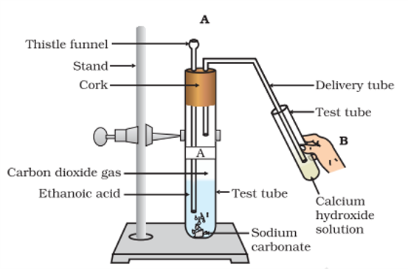

a) What change would you observe in the calcium hydroxide solution taken in tube B?

b) Write the reaction involved in test tubes A and B respectively.

c) If ethanol is given instead of ethanoic acid, would you expect the same change?

d) How can a solution of lime water be prepared in the laboratory

OR

Pratyush took Sulpher powder on spatula and heated it. He collected the gas evolved by inverting a test tube over it as shown in figure below:

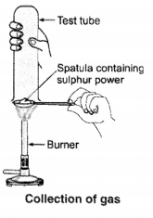

a) What will be the action of gas on

(i) Dry litmus paper?

(ii) Moist litmus paper?

b) Write a balanced chemical equation for the reaction taking place.

36. State the changes that take place in the uterus when:

a) Implantation of embryo has occurred.

b) Female gamete/egg is not fertilized.

Or

Name the parts mentioned in diagram and write each function of it

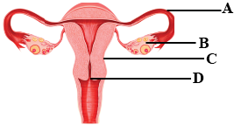

**SECTION E**

37. Observe the table and answer the questions from (a) to (c).

|  |  |
| --- | --- |
| Substance | Resistivity |
| A | 1.6 × 10-8 Ω m |
| B | 44 × 10-8 Ω m |
| C | 2.63 × 10-8 Ω m |
| D | 2300 Ω m |
| E | 1017 Ω m |

(a) Which of the above substances can be used as an insulator? [1]

(b) Which of the above substances can be used for the purpose of domestic wiring? [1]

(c)Which of the above substances is used for making solar cells and transistors? Give Reason. [2]

## OR

Which of the above substances is an alloy? Why

38. Silver articles become black after some time when exposed to air. This is because it reacts with sulphur in the air to form a coating of silver sulphide.

* Copper reacts with moist carbon dioxide in the air and slowly loses its shiny brown surface and gains a green coat. This green substance is copper carbonate.

* Iron when exposed to moist air for a long time acquires a coating of a brown flaky substance called rust. Let us find out the conditions under which iron rusts.

i) Write a chemical reaction occur during the rusting of iron.

ii) Give three methods to prevent the corrosion of metal.

iii) What do you meant by the alloy? Give one example.

iv) What is meant by Galvanization.

39. A scientist cross pure-bred tall (dominant) pea plant with pure-bred dwarf (recessive) pea plant he will get pea plants of F1 generation. If now self-cross the pea plant of F2 generation is done, then we obtain pea plants of F2 generation.

(a) State the type of plants not found in F2 generation but appeared in F2 generation, mentioning the reason for the same

(b) State the ratio of tall plants to dwarf plants in F2 generation. Write the full form of DNA.

(c) What do the plants of F1 generation look like?

(d) What is the technical name of Pea plant

***\*\*\* ALL THE BEST \*\*\****